Lily
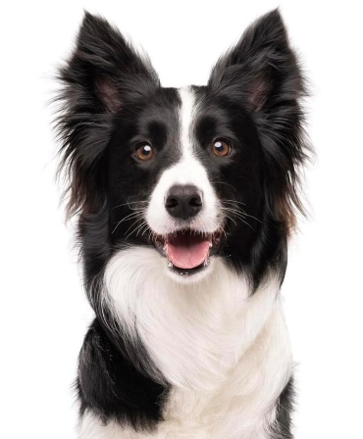
Handler Information:
Lisa Morrissey
Cell: 727-808-6724
Email: Lisa@trickdogu.com

Breed Information:
Border Collie

Type Information:
Age: 5 years
Color: Black & White
Weight: 32lbs
Height at Withers: 18”

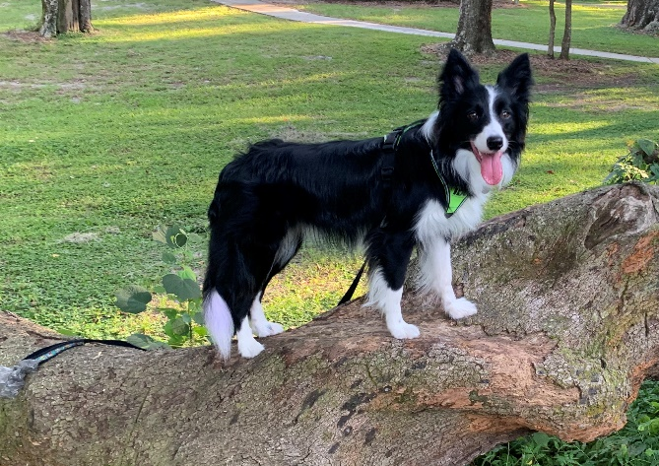

Education:
Obedience Trained (American Kennel Club Canine Good Citizen & Community Canine)
Certified Therapy Dog (Sharing Our World Therapy Dog)
Animal Actor Certified (Do More with Your Dog Level 5)

Education Continued:
Trick Trained (Do More with Your Dog Trick Dog Trick Dog Grand Champion, American Kennel Club Elite Trick Dog Performer)
Parkour Trained (All Dog Parkour Novice Trick Dog)
Canine Conditioning Trained (Canine Conditioning Level 1)
Flyball Trained (NAFA Flyball Master)
Dock Jumping Trained (NADD Dock Junior)

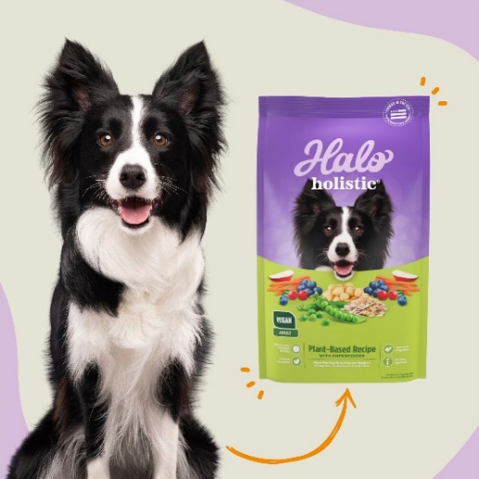

Skills:
Accepts Handling
Go to Mark (Multiple Markers, Invisible Mark)
Follows Eyeline (Handler Lure Stick)
Sit-Stay
Down-Stay
Leave It
Paws Up on Objects
Pedestal/Table
Loose Leash Walking
Auto Sit
Holds Item with Mouth
Carries Item by Mouth
Hold Item/Person/Animal with Paws (Hug)
Paw Target
Nose Target
Jump Up
Jump Over
Go Around
Go Under
Sit-Pretty/Beg
Skills Continued:
Limp
Leg Hike (Rear Leg)
Shame
Back up & Back onto a raised Object
Handstand
Tuck into a suitcase or other tight spot
Spin Right & Left
Scoot Around Handler
Rollover/Wrap yourself in a blanket
Skate/Scooter
Distance Work
Basketball Dunk/Tidy your Toys
Places item from mouth onto or into another item another item (Ring Toss, Piggy Bank, Connect 4)
Pull Items by mouth (Opens & Closes Door, Cabinets and Drawers, Pulls a Wagon, Jenga & Kerplunk)
Climb a Ladder
Roll on a Barrel
Plus, much more…

Work History:
Leading Animal Actor Role in the film The Handout
Series Role in The Advocate (Season 1, Episode 3 - A Happy Hannah Birthday)
Modeling Role for Halo Pets
Fame Shot Live Commercial
Action Model for Rick Sammon Photography School
8th Annual Dog Days Event Live Trick Dog Performance

Recent Awards:
Qualifier 2023 AKC Virtual Tricks Contest
#1 Border Collie 2023 AKC Virtual Tricks Contest
2023 International Trick Dog Competition
Task 1 Champions Level, 5th Place.
Task 2 Champions Level, 7th Place.
Task 3 Champions Level, 3rd Place.
Task 4 Champions Level, 3rd Place.
Task 5 Champions Level, 6th Place.
Task 6 Champions Level, 2nd Place.
Task 7 Champions Level, 1st Place and Creative Tricks Awards for Lily performing tricks blind folded.
Overall 4th Place for all 7 Tasks Champions Level
On set for the Advocate
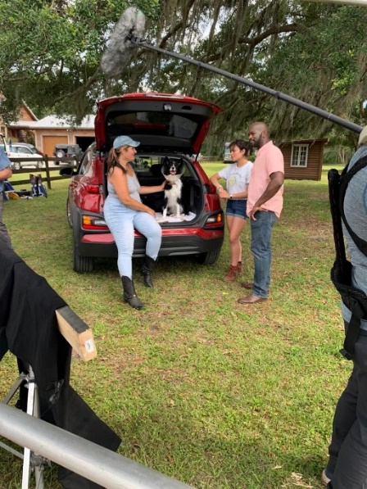
Favorite Hobbies:
Flyball
Parkour
Dock Jumping
Tugging
Trick Training
Painting
Playing Connect 4 & Jenga with her human

Photo from the set of the Handout, for scale purposes:
